ENVIRONMENTAL AND SUSTAINABILITY POLICY

Core to Cloud strives to be a leader in environmental sustainability and believes that a successful future for our business and our customers depends on the sustainability of the environment, communities and economies in which we operate.

Environmental Commitments:
- Core to Cloud will protect the environment, including preventing pollution, through responsible management of our operations;
- Will give appropriate weight to this environmental policy when making future planning and investment decisions;
- Will reduce resource consumption, waste and pollution in our operations;

Compliance:

- Core to Cloud will comply with, or exceed, our environmental obligations, including taking a positive approach regarding environmental legislation that affects our business.

This statement was approved by the board of directors, and will be reviewed annually as part of ongoing internal audit process:

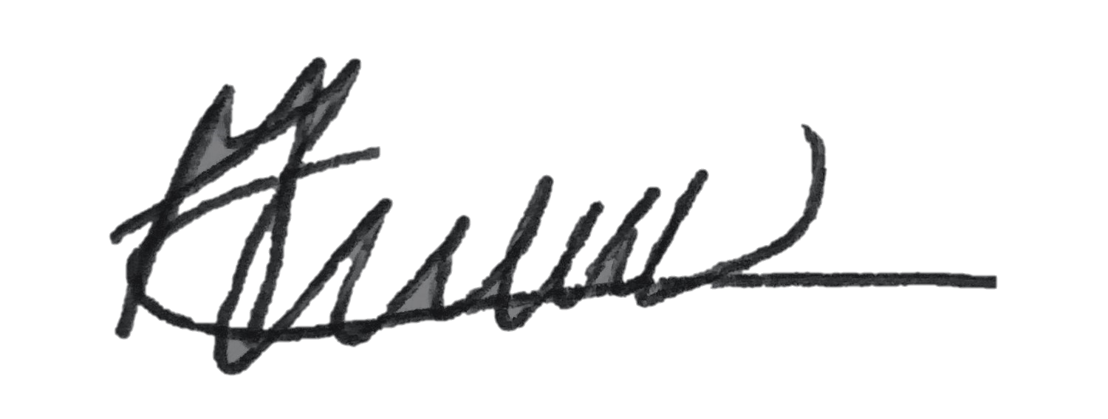

Mark Liddle, COO
Core to Cloud Ltd
12th June 2023

